ANALYSING THE PERFORMANCE AND EFFICIENCY OF RADISSON HOTELS USING DATA VISUALISATION TECHNIQUES

INTRODUCTION:

1.1 Overview

**Project Description:**

The hotel industry is a broad category of businesses that provide lodging services for travellers and tourists. This can include a wide range of establishments, from luxury resorts to budget-friendly motels, as well as extended stay hotels, boutique hotels, and more. Hotels can be found in nearly every corner of the world, and are often a major component of the tourism and travel industry in a given area.

Radisson owns multiple five-star hotels across India. They have been in the hospitality industry for the past 100 years. Due to strategic moves from other competitors and ineffective decision-making in management, Radisson is losing its market share and revenue in the luxury/business hotels category. As a strategic move, the managing director of Radisson wanted to incorporate Business and Data Intelligence in order to regain their market share and revenue. Our task is to create an analytics dashboard & story to provide them insights to make better business decisions.

1.2 Purpose:

* The use of data analytics in the hotel industry is essential for increasing productivity, efficiency, and profitability. The outcomes of data analysis informs a business where they can optimize, whether operations need improvement, which activities can gain higher efficiency, and more.
* One of the most important elements of a successful hotel and a flawless guest experience is having efficient hotel operations systems. Guest expectations are rising, and they desire a seamless experience at a hotel. Increasing a hotel's operational efficiency is key to customer satisfaction.
* This is easily one of the most important metrics in the hotel business for several reasons. First, it gives you a firsthand view of how your hotel is performing when it comes to selling rooms. Additionally, occupancy rate lays the groundwork to measure more important KPIs.
* Performance measurement is the process used to assess the efficiency and effectiveness of projects, programs and initiatives. It is a systematic approach to collecting, analyzing and evaluating how “on track” a project/program is to achieve its desired outcomes, goals and objectives.

PROBLEM DEFINITION AND DESIGN THINKING:

2.1 Empathy map:

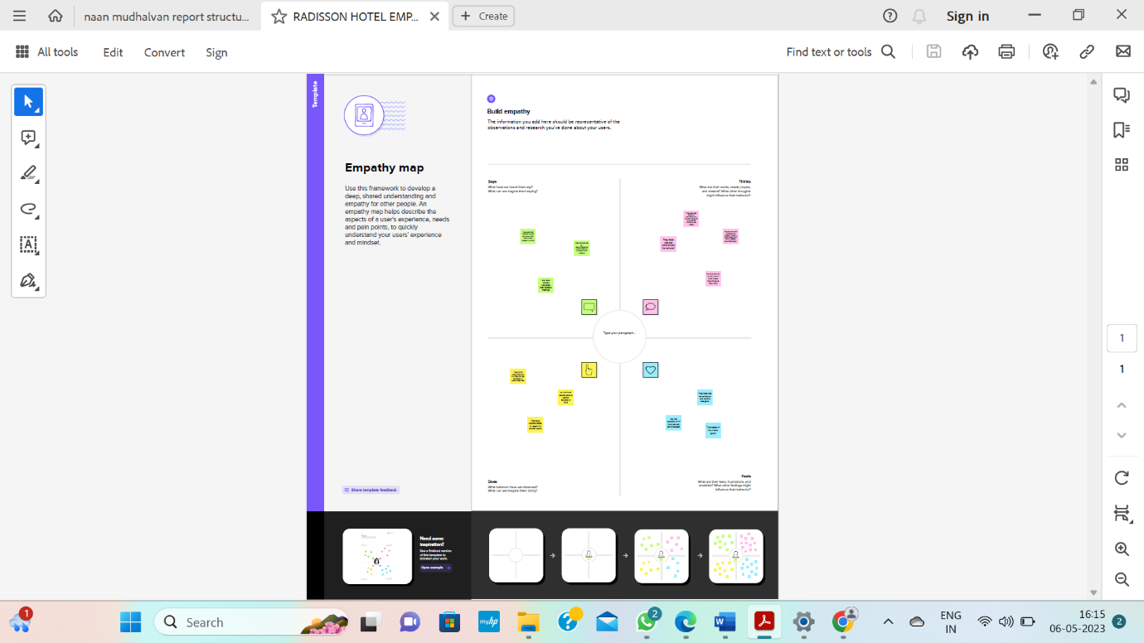

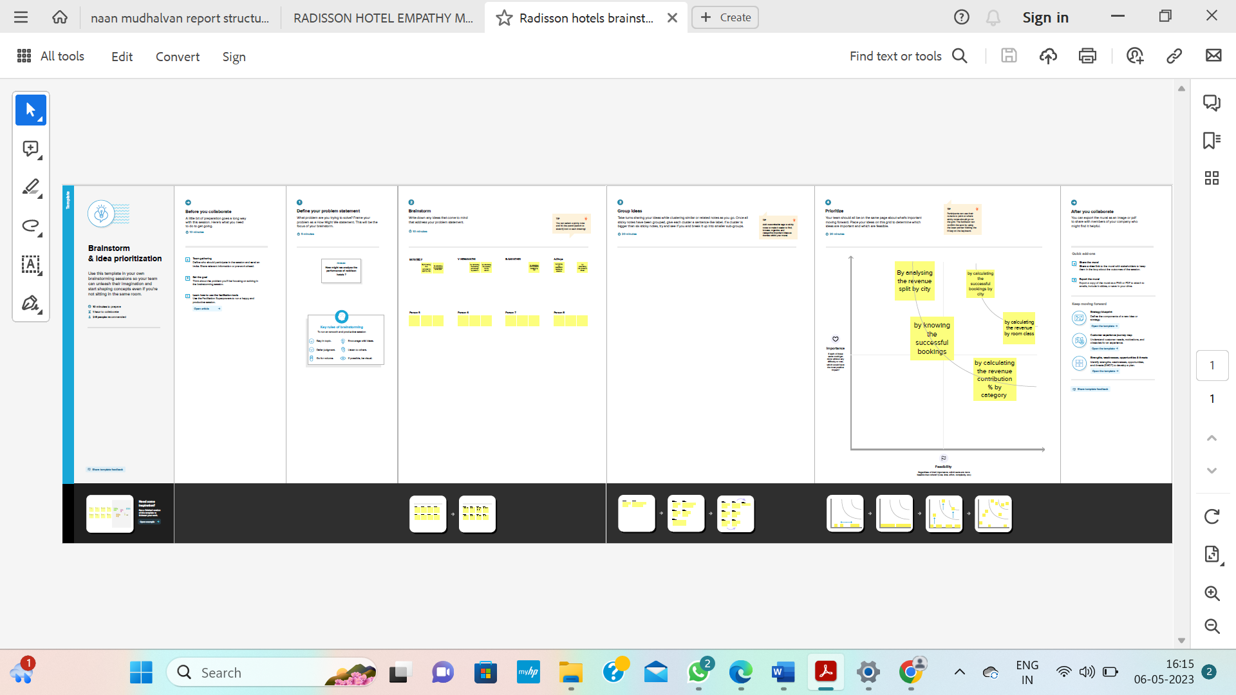2.2 Ideation and brainstorm map:

RESULT:

Innovation in the hotel environment can be found in review processes, by consulting consumer trends and employing fitting IT systems, for instance. The [**Hospitality Innovation Industry Report**](https://hospitalityinsights.ehl.edu/hospitality-innovation-strategy-in-practice?_ga=2.114452423.1501349849.1599481794-460734372.1576662809) distinguishes between technological and non-technological innovation.

**Technological innovation:**

* Technology innovation, e.g.:
  + adapting to new technological capabilities online interaction with guests
  + technology-assisted personalization
* Service innovation, e.g.:
  + unique, superior services
  + a compelling value proposition
* Process innovation, e.g.:
  + standardization
  + modernization
  + bringing together consumer experience, e-commerce, big data and digital transformation, and revenue growth analytics

**Non technological innovation:**

* Management innovation, e.g.:
  + agile management principles
  + collaborative user-oriented and supplier relationships
* Organizational behavior, e.g.:
  + optimizing work processes
  + establishing alternative employee management approaches
  + fostering internal leadership
* Marketing innovation, e.g.:
  + creating online brand communities
  + introducing new loyalty programs
  + utilizing social media analytics
* Business model innovation, e.g. incorporating:
  + the Internet of Things
  + blockchain
  + 3D printing
  + artificial intelligence

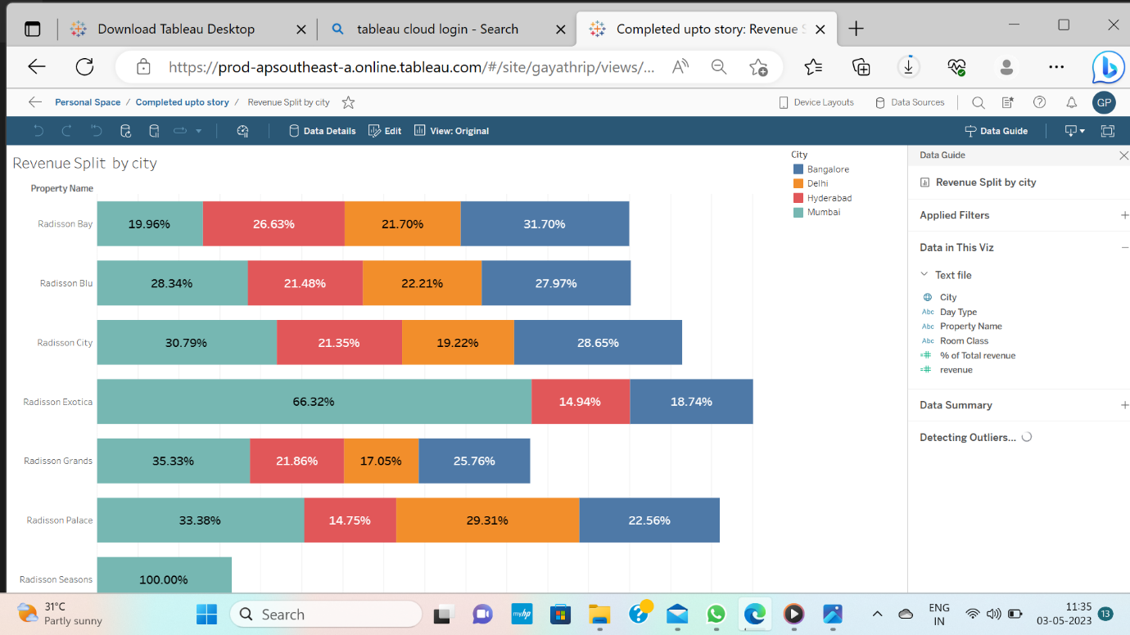

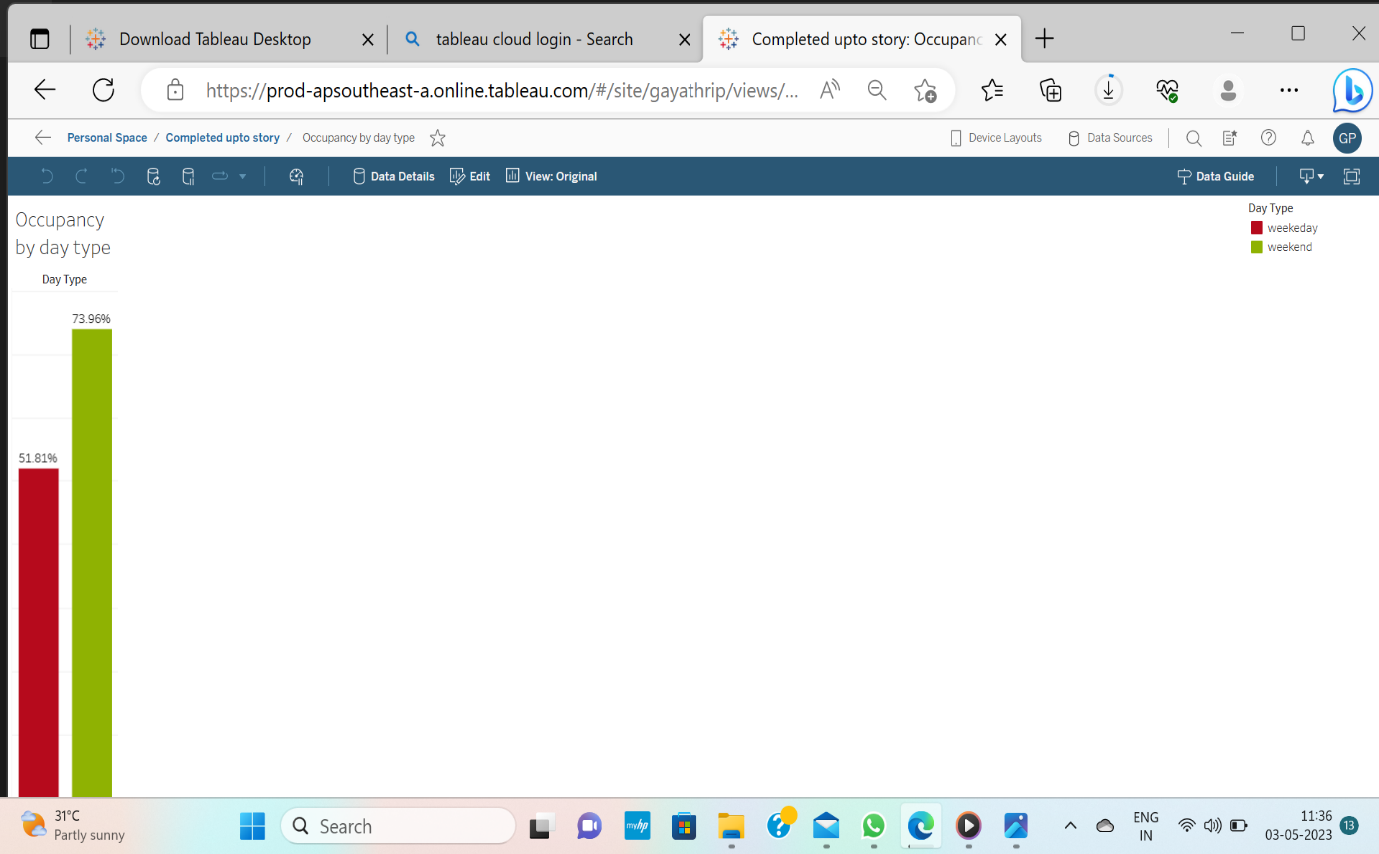

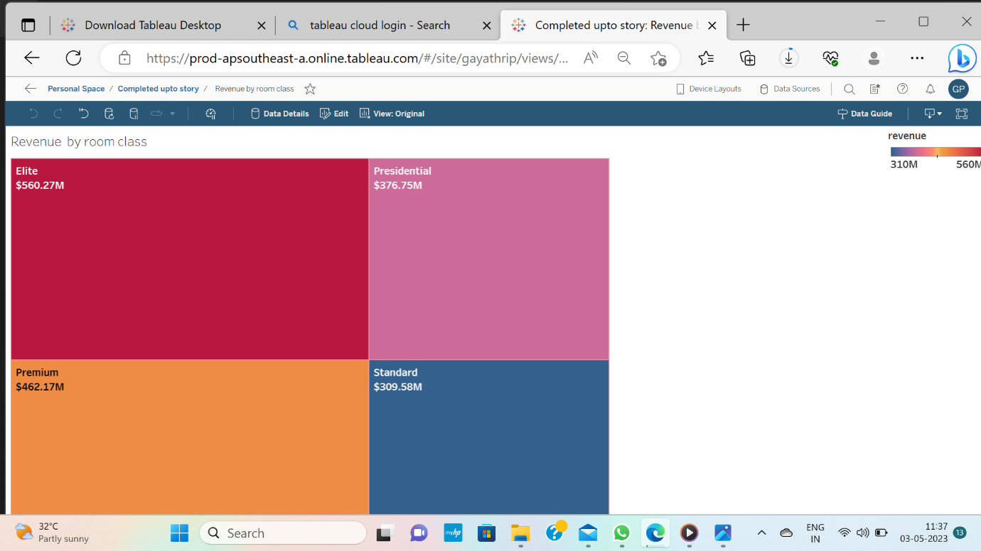

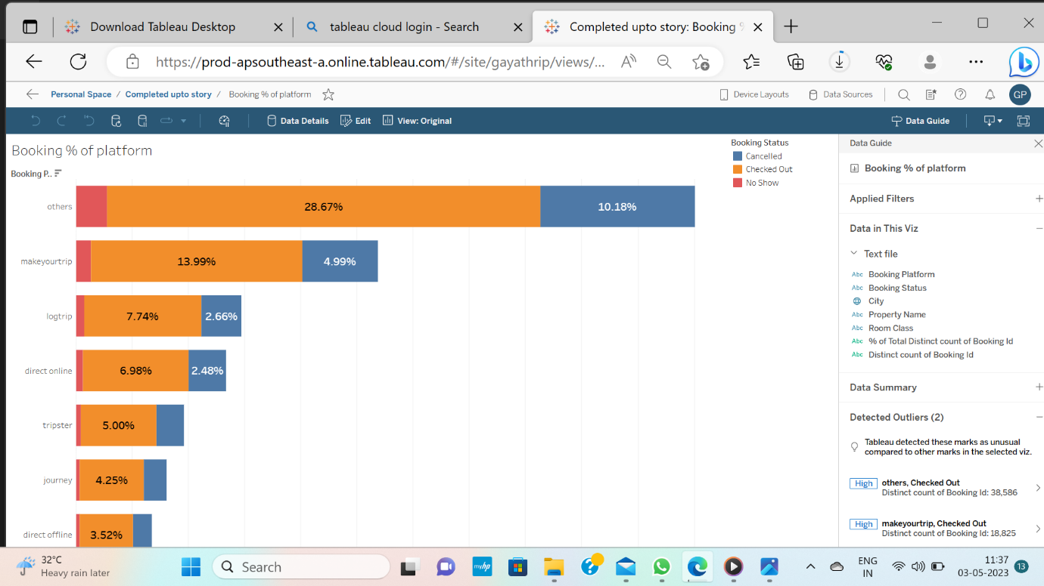

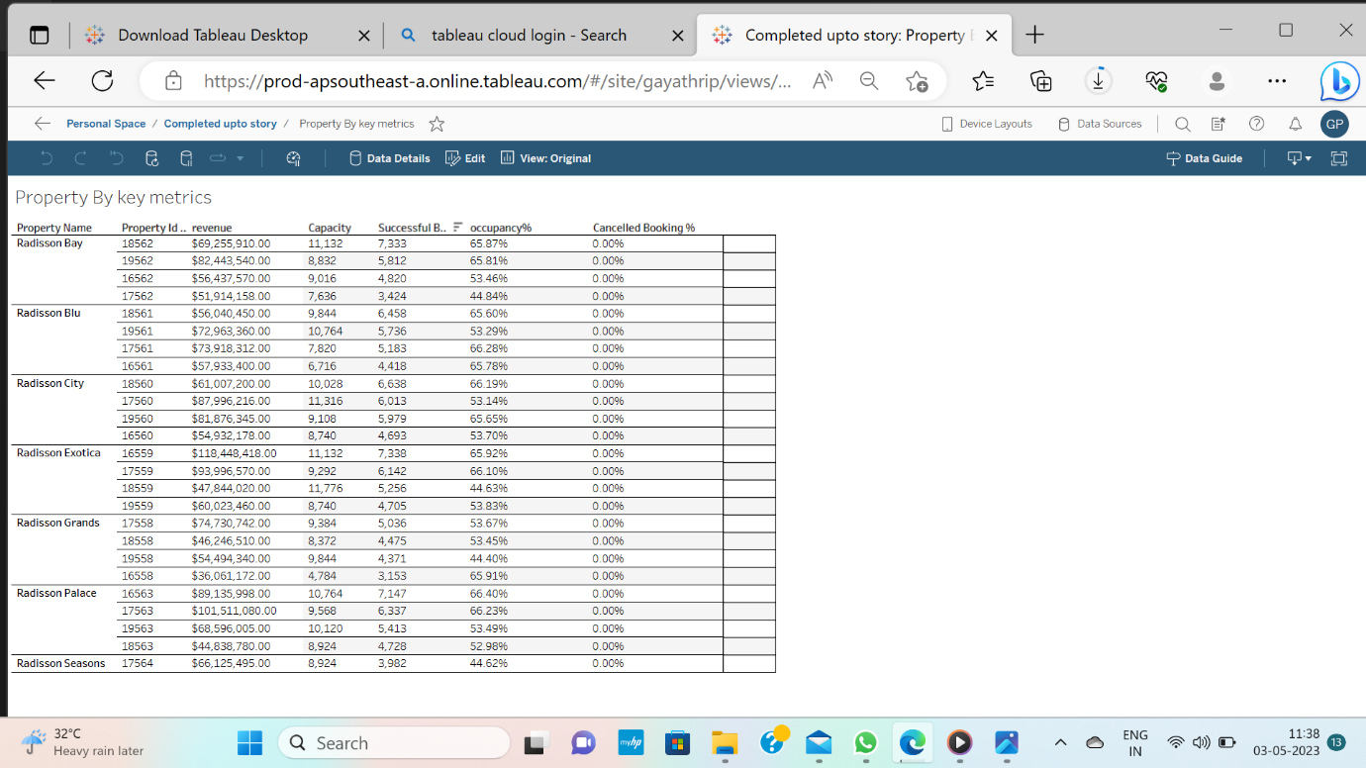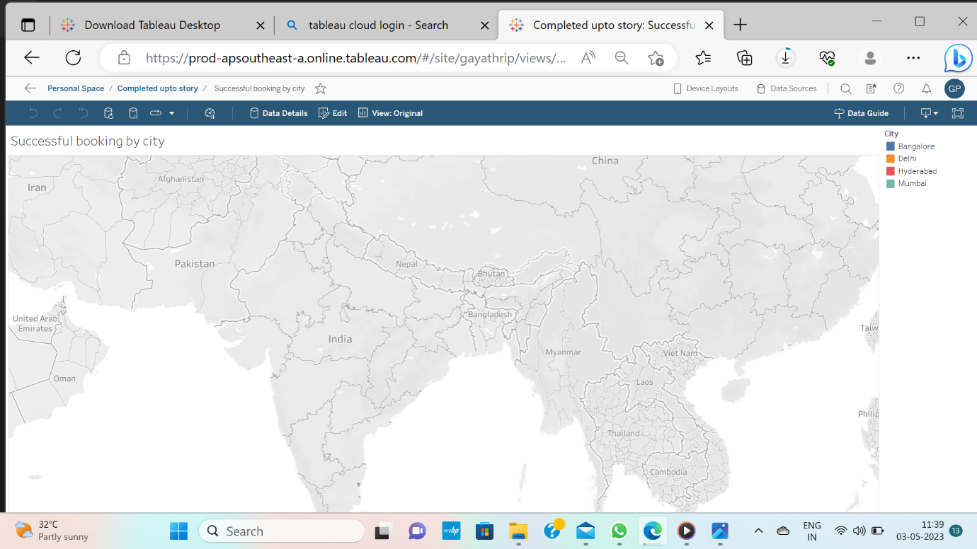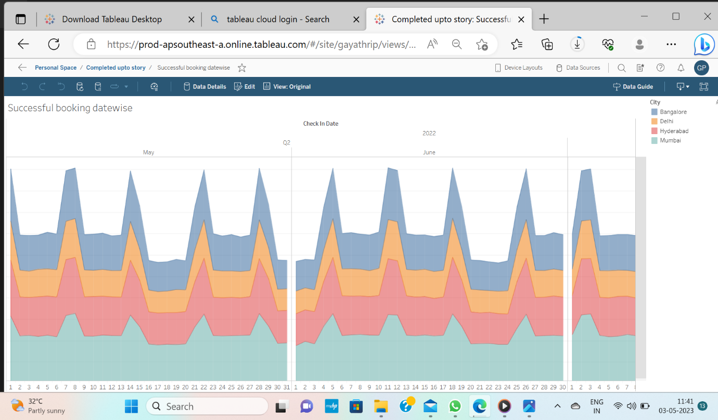ADVANTAGES :

**Working environment –**The working environment of hotel industry is very good compare to other industry. You see around your smiley people and you fill energetic. And Maximum people are helpful.

**Easily Get Job –**If you have hospitality degree you can find job anywhere. There are lot of opportunities other than hotel waiting for you like in Airline Catering, Cruise ship etc.

**Opportunities to Go in other Countries –** If you hotel management you can get job in foreign country. This is the best option for who like to work in other country.

**Growing Industry –** This is fastest [growing](https://www.marketresearch.com/Netscribes-India-Pvt-Ltd-v3676/Hotel-India-12379982/#:~:text=The%20hotel%20industry%20in%20India,foreign%20tourists%20and%20business%20delegates.) industry. The hotel industry in India is expected to reach a value of INR 1210.87 Bn by the end of 2023.

**Pleasing Personality –** If you do hospitality management your personality will be become pleasant. You learn about how to speak people. I think neither degree teach you better than Hospitality degree How our attitude towards to people in hotel or our personal life.

DISADVANTAGES:

I made a survey in my hotel I ask people how you fill now joining hotel industry about 70 to 75% people regreting the joined hotel industry.

So please decide this industry made for you or not. I am not demotivate you here because I am also hospitality student. If you are really interested in Hotel and Tourism then this industry only for you.

**Long Shifting hour –** You can see other jobs time to time but hospitality industry not. If you become chef there is long Shifting hour like above 12 hour.

**Stress –** This industry gives you lots of stress. If you are at Managerial level then stress of your company growth. And you are lower level then there is stress of working.

**Initial Salary Very less –** In hotel industry initial Salary is very less compare to other industries. If you go higher level or managerial level it also increases.

**Forget about Vacation –** You have enough amount of holidays and vacations your friends celebrate Diwali and here you work in hotel.

**Initially forget about Family life –** Initially neither gets enough amount of holidays.

Application:

The service profit chain theory suggests that the satisfied employee delivered customer satisfaction and profit for service businesses. Competition between tourist hotels in Taiwan remains strong, as trips by foreign visitors are increasing year after year. One of the critical factors that differentiate whether or not a hotel can be profitable is the revenue per employee. Satisfied employees whose [organizational citizenship behavior](https://www.sciencedirect.com/topics/social-sciences/organizational-citizenship-behavior) (OCB) is high will generate a higher ratio of revenue per employee. This study explores the key factors that effectively drive job satisfaction of the employees in an international tourist hotel. The study collected 474 valid employee responses. It applied an importance-performance analysis (IPA), using the self-explained matrix, which indicated that compensation was the top issue to be addressed, followed by work environment, [interpersonal relationship](https://www.sciencedirect.com/topics/social-sciences/human-relation), and supervision. Based on the research results, the author discusses some useful implications.

Conclusion:

The competition in the hotel business is strong, as the number of international visitors continues to increase, including those from mainland China after the deregulation of cross-strait travel, and more hotels continue to join the market. The rate of revenue per employee has become one of the crucial factors that determines whether or not a hotel will be profitable. Job satisfaction is the basis for organizational citizenship behavior (OCB) and is the core factor involved in customer.

Future scope:

With the escalating demand of hotels in India, the hotel management industry has huge growth potential in the near future. The demand for smart and skilled professionals in this industry is growing at a fast pace, not only in India but also worldwide.

There is a dire need for skilled and retainable professionals. In this era of social media, everyone is aware of what to expect in a hotel and the standards one needs.

Advanced technologies are introduced in the industry such as Mobile door key instead of plastic cards, Mobile hub spots where everything in the room can be controlled by one remote room phone. Faster Wi-Fi’s having better bandwidths.

These technologies will revolutionalize the hotel industry to the next level. As technology innovations continue to transform every industry and job role, the hotel managing industry is certainly no exception.

In the near future automation will be a great part of hotel management industry too: Speak to order platforms will be trendy by which a virtual assistant will manage everyday mundane tasks, such as taking simple food orders and explain all the queries a customer has.

Cloud services will be available such that a person will have entertainment on tap. You no longer have to visit restaurants anymore, the food and services you need will avail to you at home, ordering food online has become a recent update provided.

The hotels will help us in having a smarter and meaning experience in the next decade.

Appendix:

Source code:

* My SQL